18th May 2017

**YOKOHAMA in Europe celebrates Chelsea FC Championship**

Jubilant scenes among the members of the YOKOHAMA family were evident, not only at Stamford Bridge, but across Europe last week, as Chelsea’s victory at West Bromwich Albion secured the title for the Blues for the first time since the Japanese premium tyre manufacturer YOKOHAMA is the Official Shirt sponsor of Chelsea FC. Currently on its second season of Sponsorship YOKOHAMA has sought to reach out to more people thanks to the Global appeal of Chelsea FC and the sharing of common values which include performance and innovation and an unwavering culture of success. Across Europe many of YOKOHAMA staff sported the “Blues” shirts and scarfs whilst they celebrated the achievement.

A spokesman for YOKOHAMA Europe expressed delight with the “magnificent achievement” of Chelsea FC players and staff and congratulated them all wholeheartedly.

“We are very happy for the Club, the fans and for everyone associated to Chelsea FC. Achieving this success is only possible through teamwork, efficiency and clear direction and Chelsea have shown all of these in great measure and has resulted in being crowned Champions.” Added the spokesman.

“As an additional plus, we are looking forward to more Chelsea FC success and particularly to Chelsea FC participation next year in the European Champions League. This will help our brand visibility even further on a European and Global scale”, concluded the spokesman.

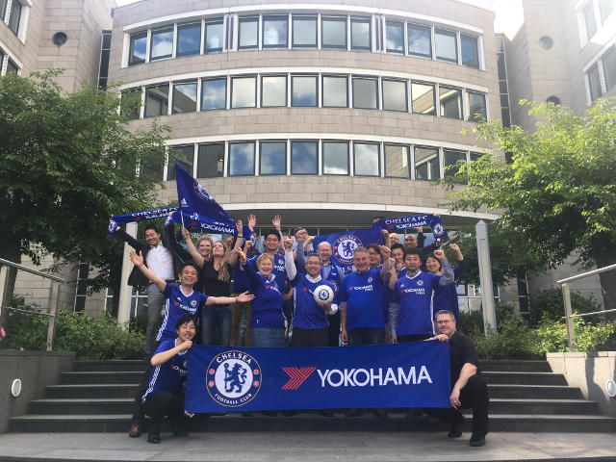

*YOKOHAMA Europe celebrates Chelsea FC as Champions*

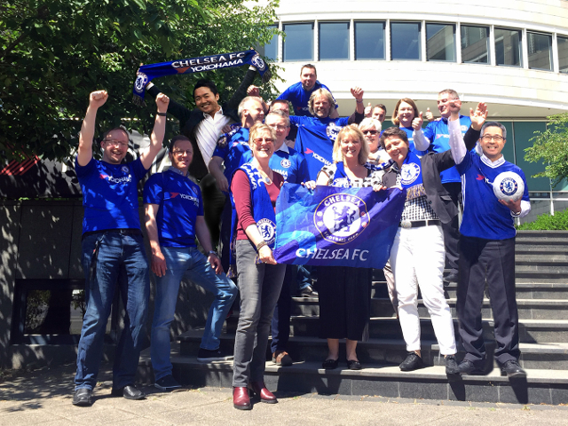

*YOKOHAMA Germany celebrates Chelsea FC Triumph*

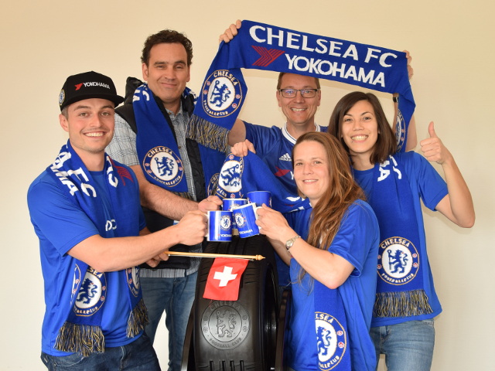

*YOKOHAMA Switzerland celebrating*

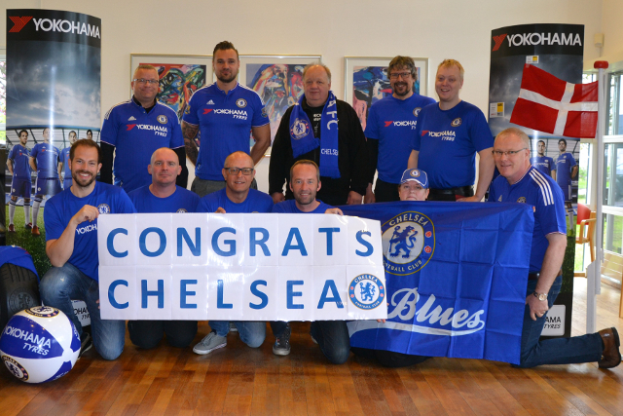

*Congrats Chelsea from YDA (YOKOHAMA Denmark)*

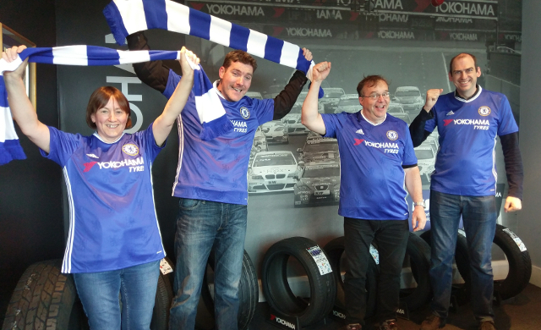

*YOKOHAMA UK Office team celebrating Chelsea FC Championship*

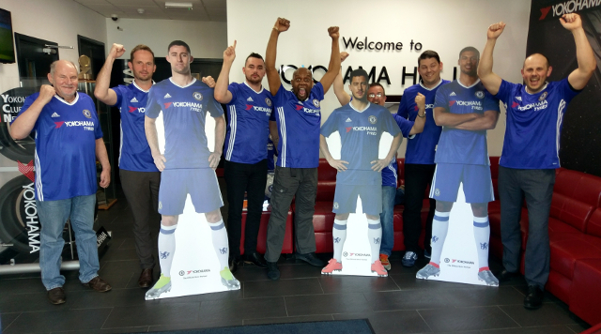

*YOKOHAMA UK Sales Dept celebrations*

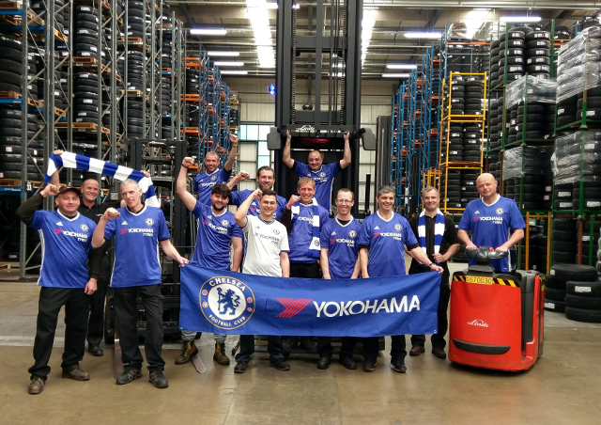

*YOKOHAMA UK Warehouse celebrations*